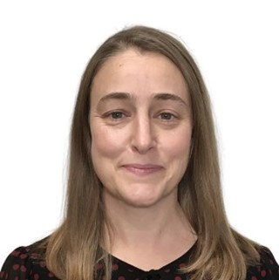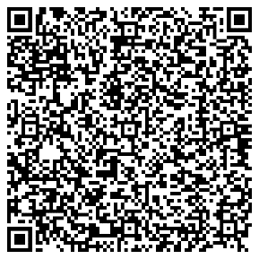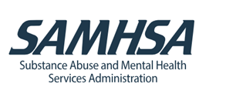

Happy Summer!
Did you know that many of the resources and answers that you are looking for regarding pediatric, adolescent, and caregiver mental health and substance use disorders are easily available for free? No need to reinvent the wheel! I am a pediatrician and adolescent specialist in Boston. I have been in clinical practice for 24 years and I joined Region One of the US Department of Health and Human Services Substance Abuse and Mental Health Services Administration (SAMHSA) in May 2024 as a Regional Behavioral Health Advisor. Regional Behavioral Health Advisors serve as local consultants, liaisons, and resources to individuals, local, state, and tribal entities. Region One includes Connecticut, Maine, Massachusetts, New Hampshire, Rhode Island, and Vermont.
Once I joined SAMHSA, I discovered all these remarkable resources that are available on demand or live and I HAD NO IDEA existed and I would have loved to use them in clinical practice. Here are a few wonderful resources:
- National Maternal Mental Health Hotline at 1-833-TLC-MAMA offers 24/7 support via call or text for those who are pregnant or recently had a baby.
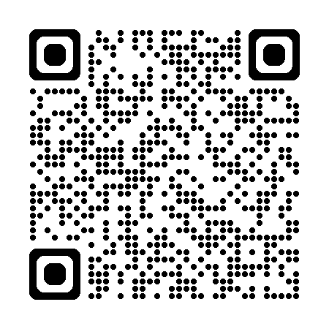

- SAMHSA’s National Helpline at 1-800-662-HELP (4357) is a free, confidential, 24/7, 365-day-a-year treatment referral and information service (in English and Spanish) for individuals and families facing mental and/or substance use disorders. Home - FindTreatment.gov offers additional resources.

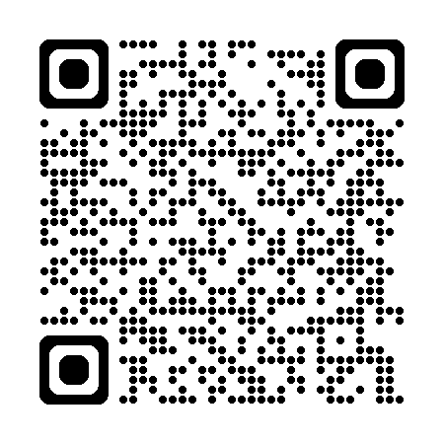
- National Child Traumatic Stress Initiative (NCTSI) | SAMHSA Access information for parents and caregivers, military families, educators, health professionals, media, and others responding to child traumatic stress. Find technical assistance for professionals seeking support and training on child traumatic stress.

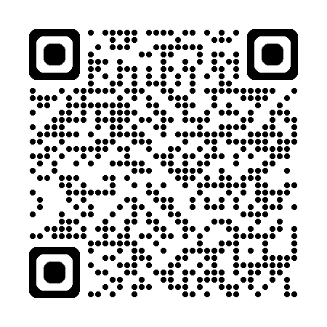

- SAMHSA Practitioner Training available at Practitioner Training | SAMHSA offers tools, training, and technical assistance for mental health and substance use disorders.

- Technical Training Assistance Centers offer live and recorded webinars, workshops, and roundtable discussions on a large variety of topics. Particularly helpful are:

- Mental Health Technology Transfer Centers (MHTTC)
The MHTTCs work with organizations and treatment practitioners involved in the delivery of mental health services to strengthen their capacity to deliver effective evidence-based practices to individuals, including the full continuum of services spanning mental illness prevention, treatment, and recovery support. Topics include youth substance use prevention, treatment, and recovery, anxiety, depressions, ADHD, and more.
Prevention Technology Transfer Center (PTTC) Network (pttcnetwork.org)
The PTTCs develop and disseminate tools and strategies needed to improve the quality of substance abuse prevention efforts; provide intensive technical assistance and learning resources to improve understanding of prevention science, how to use data to guide prevention planning, and selection and implementation of evidence-based and promising prevention practices.
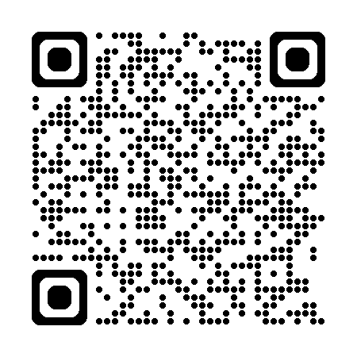

- The Centers of Excellence are partnerships between SAMHSA and subject matter experts for specific health concerns or communities. Particularly helpful are:

- National Center of Excellence for Eating Disorders (NCEED) offers on demand webinars, best practices and clinical reports from major organizations, Toolkit: infographics, checklists, videos, Web-Based Training in Enhanced CBT (CBT-E) for eating disorders, and Family, friends, and individual resources.
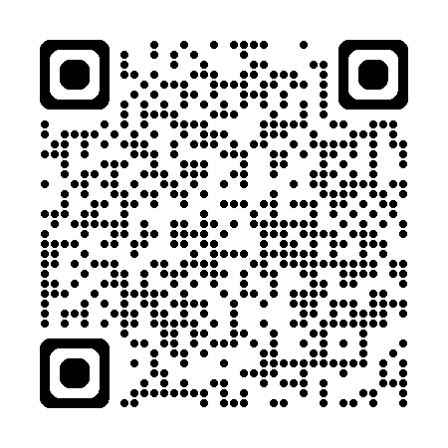

- Center of Excellence on Social Media and Youth Mental Health is a collaborative with the AAP and serves as a centralized, trusted source for evidence-based education and technical assistance to support the mental health of children and adolescents as they navigate social media. It offers the 5 Cs of Media Use, a Q&A Portal, Youth Advisory Panel, Family Media Plan, Family Tip Sheet, and Multimedia Resources.

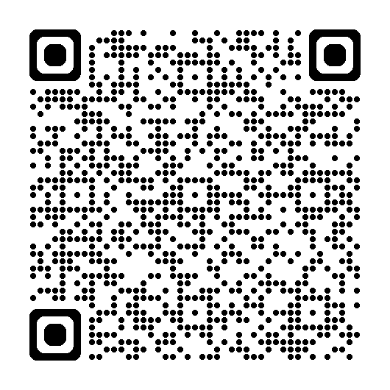

Finally, I am a resource to you and your practice. Please reach out and I will do my best to support you, network you with others, or provide resources, etc. I look forward to working with you.
Laura K Grubb MD MPH
Regional Behavioral Health Advisor
Region One: CT, MA, ME, NH, RI, VT and 10 sovereign tribal nations
Substance Abuse and Mental Health Services Administration (SAMHSA)
15 Sudbury Street, Suite 1826
Boston, MA 02203
202-961-6558 (cell)
Laura.grubb@SAMHSA.HHS.GOV
SAMHSA - Substance Abuse and Mental Health Services Administration

